**DESIGN PROJECT REPORT**

**NAVIGATION AID FOR VISUALLY IMPAIRED**



MENTOR: Dr. DINESH KUMAR V.

GROUP MEMBERS:

1. Aryan (22BSM010)

2. Amit Kumar (22BEC011)

3. Aman Dhoke (22BCS024)

4. Satwik Baruri (22BDS034)

5. Shreyansh Tripathi (22BME057)

6. Archakam Sree Chaitanya(22BCS041)

**ACKNOWLEDGEMENT**

We take great pleasure in expressing our deep sense of gratitude to our esteemed institute, **PANDIT DWARKA PRASAD MISHRA INDIAN INSTITUTE OF INFORMATION TECHNOLOGY, DESIGN AND MANUFACTURING, JABALPUR**, for providing us with the opportunity to undertake this project. The institution’s unwavering commitment to academic excellence and innovation has played a crucial role in shaping our knowledge and technical skills.

We are profoundly grateful to our esteemed project mentor, **Dr. Dinesh Kumar V.,** for his invaluable guidance, encouragement, and continuous support throughout the duration of this project. His expertise and insightful suggestions have been instrumental in refining our work and achieving our objectives.

We also extend our sincere gratitude to our director, **Prof. Bhartendu K. Singh,** for providing the necessary resources and infrastructure that enabled us to successfully complete this project. His vision for fostering a research-driven learning environment has greatly benefited our academic journey.

The environment at **IIITDMJ** has been a transformative experience, offering us the opportunity to learn, innovate, and collaborate in an intellectually stimulating atmosphere. This project, focused on **NAVIGATION AID FOR VISUALLY IMPAIRED,** has allowed us to explore cutting-edge assistive technology, further deepening our understanding of its real-world applications.

Lastly, we would like to express our heartfelt appreciation to our peers, faculty members, and everyone who contributed at various stages of this project. Their support, feedback, and encouragement have been invaluable in overcoming challenges and ensuring the successful completion of this work. Without their contributions, this achievement would not have been possible.

**Index**

1. **Introduction**
2. **Key Features and Merits**
3. **Needs**
4. **Hardware Components**
5. **Brif on Components used**
6. **Circuit Diagram**
7. **Design Detailing**
8. **Working**
9. **Novelty**
10. **Bill of Materials**
11. **Conclusion**

**INTRODUCTION**

Visually impaired individuals often face challenges in independent navigation, relying on white canes, guide dogs, or mobile applications for assistance. However, these methods have limitations, such as the need for constant manual handling, dependence on auditory instructions, and limited obstacle detection capabilities.

To overcome these challenges, we propose a haptic-based navigation aid in the form of a wearable device, designed to provide real-time spatial awareness through haptic (vibrational) feedback and audio descriptions using air conduction earphones. This device integrates LiDAR-based depth sensing, and real-time environmental analysis to guide users through various surroundings, enhancing their mobility and independence.

Unlike traditional navigation aids, this hands-free wearable allows users to move freely without needing to hold a device, making it an ideal companion for indoor and outdoor mobility. The device is designed to be lightweight, comfortable, and efficient, ensuring long-term usability with minimal power consumption.

**Key Features and Merits**

The proposed haptic navigation aid offers several advantages over traditional assistive technologies:

**1. Hands-Free Navigation**

Unlike white canes or handheld devices, this wearable system allows users to move freely without carrying any equipment.

Provides a more natural walking experience while keeping the user's hands available for other tasks.

**2. Multi-Sensory Feedback System**

Haptic feedback through ERM coin vibration motors placed strategically on the forehead, temples, and cheeks to indicate obstacles in different directions.

Audio guidance through air conduction earphones, allowing users to receive verbal instructions without blocking external ambient sounds.

**3. AI-Powered Object and Obstacle Detection**

Realtek AMB82 Mini IoT AI Camera detects obstacles, staircases, doorways, signboards, traffic lights, and other critical elements.

Sharp Distance Measuring Sensors (GP2Y0A21YK0F) help in short-range obstacle detection, ensuring real-time alerts.

Benewake TFMini-S LiDAR distance Sensor scans the surroundings, measuring distances up to several meters, ensuring highly accurate depth perception.

**4. Adaptive Haptic Feedback Mechanism**

The intensity and frequency of vibrations change based on the distance and urgency of obstacles.

Different vibration patterns are mapped for various obstacle types:

Strong vibration for close-range objects.

Pulsating vibrations for moving obstacles.

Directional vibrations to indicate turns or path guidance.

**5. Audio Guidance with Air Conduction Earphones**

The device uses air conduction earphones to deliver real-time voice feedback, allowing users to receive information without blocking their natural hearing.

This enables users to remain aware of their environment, such as listening for approaching vehicles, pedestrian traffic, or emergency alerts.

**6. Long Battery Life and Connectivity**

Equipped with a 20,000mAh rechargeable power bank, providing extended usage without frequent recharging.Bluetooth and WiFi module integration allow firmware updates, cloud-based AI processing, and future enhancements

**Needs**

***Why is This Device Essential?***

* White canes cannot detect overhead obstacles like signboards or fast-moving objects like bicycles or cars.
* Guide dogs are costly to train and require constant care and maintenance.
* Smartphone navigation apps depend on GPS, which does not work well indoors or in places with poor signal.

***Real-Time Awareness for Safer Navigation***

* The device provides instant feedback using vibrations and audio, allowing users to react quickly.
* Helps with avoiding obstacles, crossing streets, and identifying doorways, making navigation smoother.

***Suitable for Any Environment***

* Works both indoors (homes, offices, malls) and outdoors (streets, public transport, parks).
* Functions effectively in bright and dark environments, unlike vision-based systems that require light.

***Non-Intrusive Communication***

* Uses air conduction earphones, so users can still hear surrounding sounds.
* Allows awareness of approaching vehicles, conversations, and important announcements, ensuring safety.

**Brief On Components**

**1. Realtek AMB82 Mini IoT AI Camera Dev**

The AMB82-MINI development board is adopting Realtek RTL8735BDM SoC, it is suitable for battery-powered appliances or equipment requiring AI network camera applications, with no worry about power consumption and IoT security. AMB82-MINI is easy to program and learn AI models with this powerful AIoT development kit.

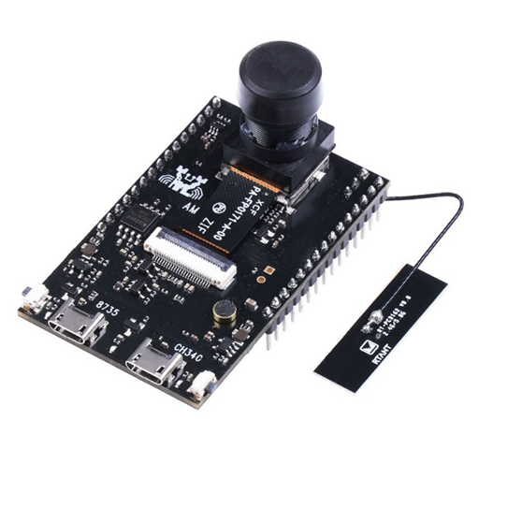

[**2. ERM Coin Vibration Motor, 8 mm Dia,2 mm Width**](https://robu.in/product/erm-coin-vibration-motor-8-mm-dia-2-mm-width/)

Coin ERM type vibration motor is very popular in the wearables field. Since the coin motor is the thinnest motor in the world, and the thinnest we can do is 2.0mm, which is suitable for a thin and light smartwatch. You can click on 7-12mm flat motor for selection. These coin motors could be of different sizes and different contact modes for your choice.

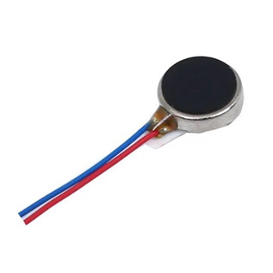

**3. Benewake TFMini-S Micro LiDAR Distance Sensor**

LiDAR sensors provide precise and reliable distance measurements using laser technology, making them ideal for autonomous vehicles, robotics, industrial automation, and environmental monitoring. By emitting laser pulses and analyzing reflection times, they enable accurate 3D mapping and object detection. These sensors are effective for both short-range and long-range applications.

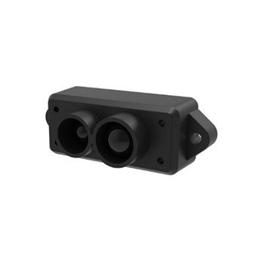

**4. Portronics Luxcell B 20K Advanced 20000 mAh Power Bank with 22.5W**

The **Portronics Luxcell B 20K Power Bank** is a compact and portable device designed for on-the-go charging. With a **20,000 mAh battery** and **22.5W high-speed output**, it ensures fast and efficient charging for your devices anytime, anywhere.

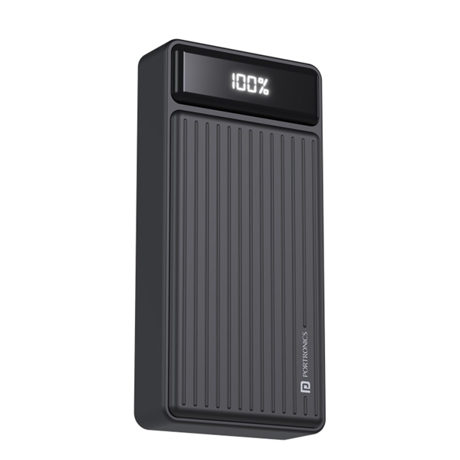

**5. Air Conduction Earphones**

Air-conduction earphones provide navigation instructions without blocking ambient sounds, ensuring environmental awareness for visually impaired users. Their lightweight and comfortable design allows extended use without discomfort. With wirelessconnectivity, they integrate seamlessly with navigation aids, enhancing mobility and safety.

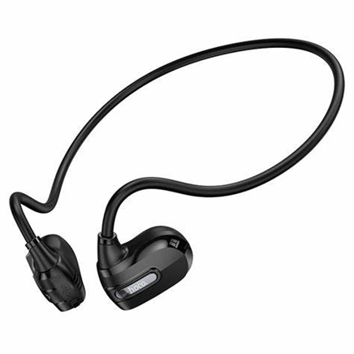

**6. NEO-6M GPS MODULE**

**The NEO-6M GPS module** offers precise and reliable location tracking, making it ideal for navigation systems. Its compact and lightweight design ensures easy integration into various devices without adding bulk. With fast satellite acquisition and stable connectivity, it enhances real-time navigation and improves mobility and safety for users.

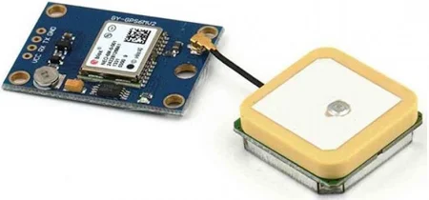

**Circuit Diagram**

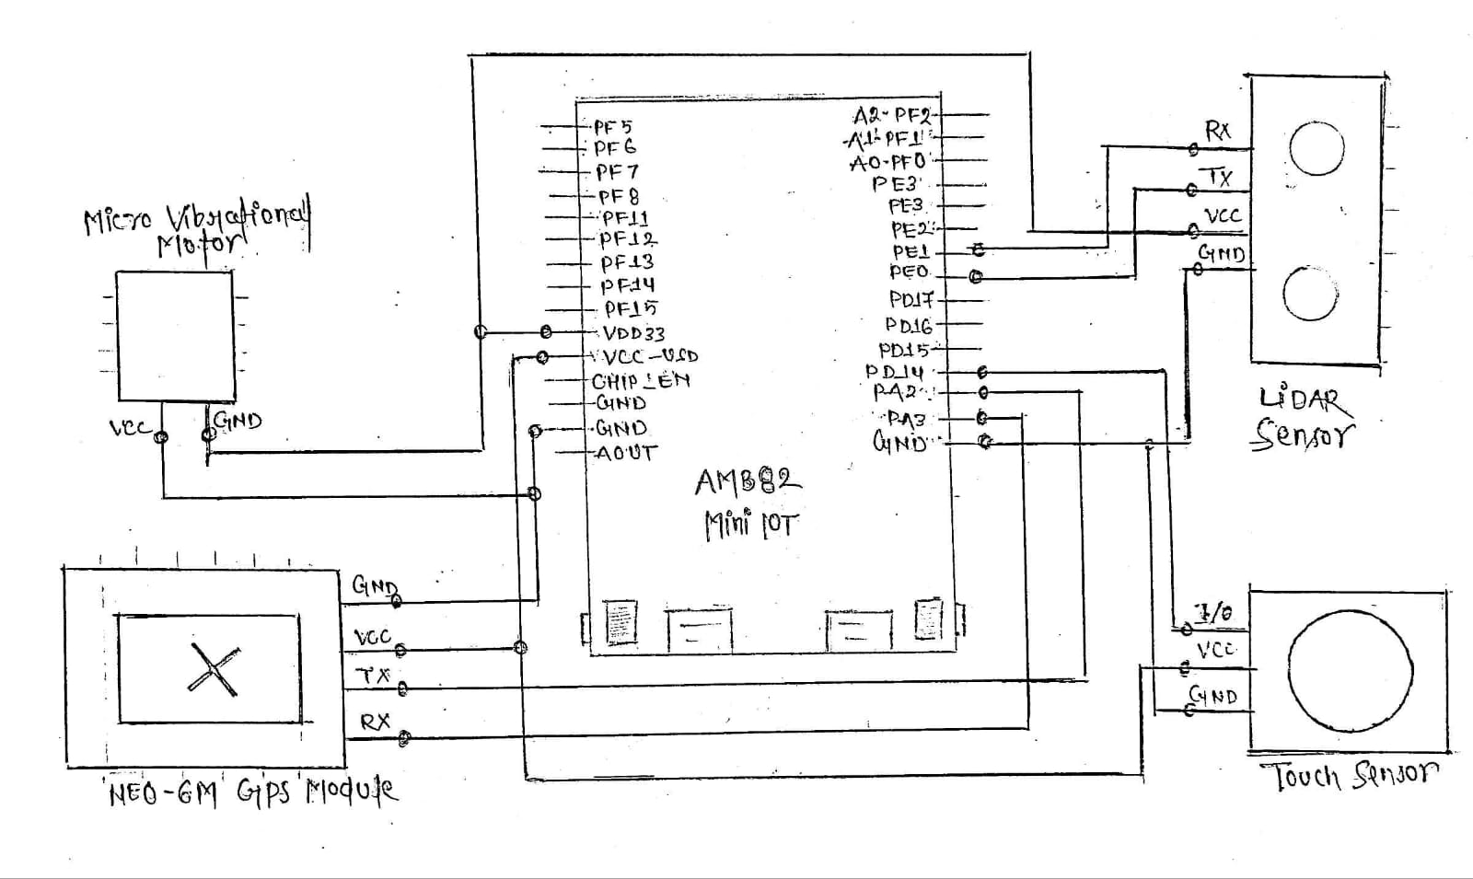

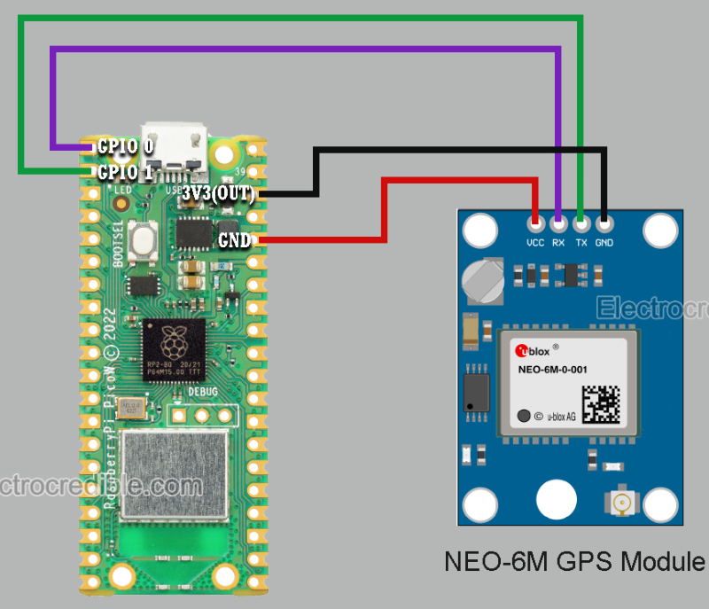 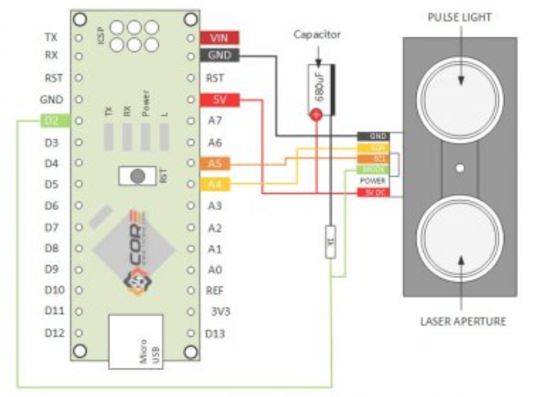

GPS Module connection with AMB82 mini LiDAR Sensor connection with AMB82 mini

**Design Detailing** 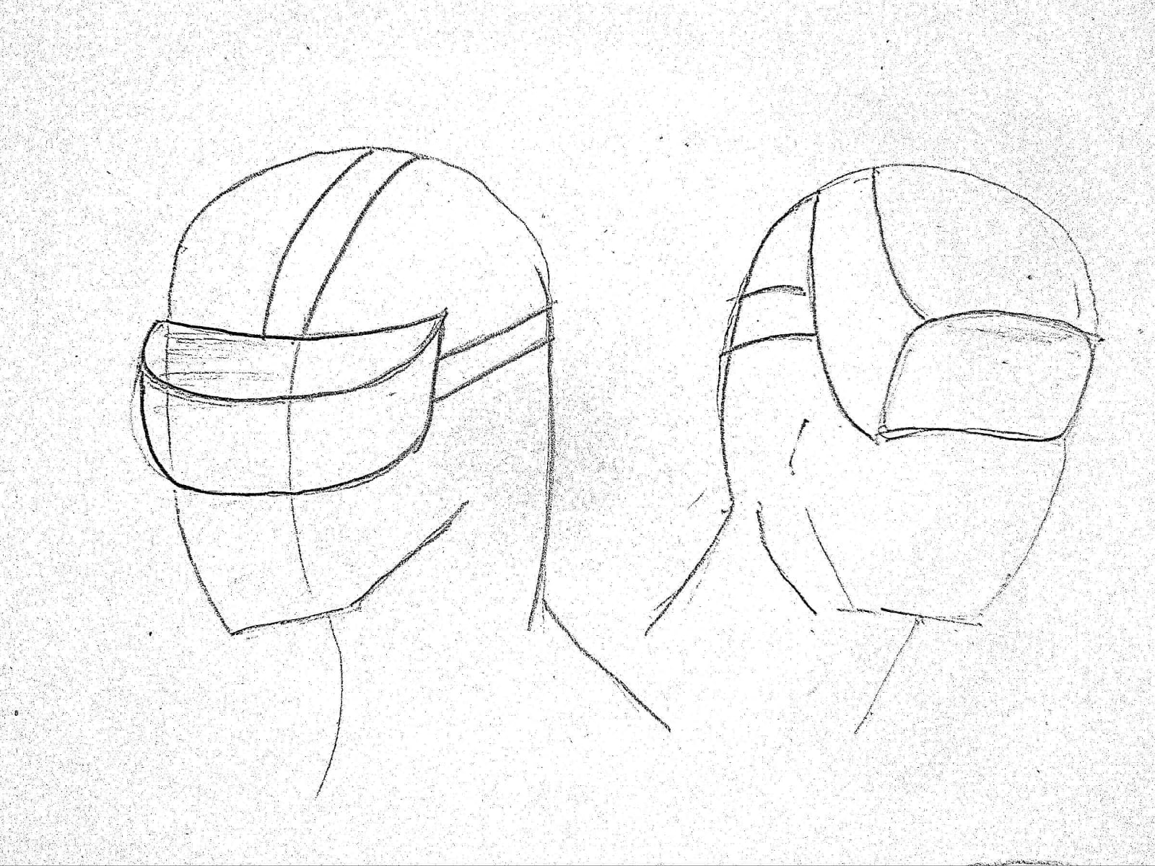

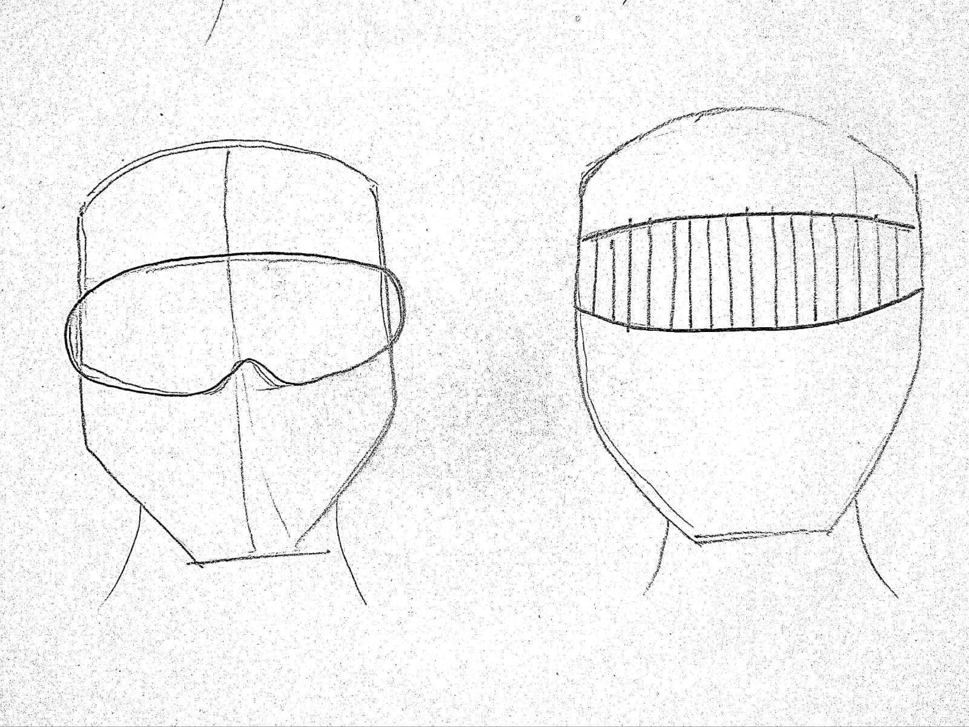

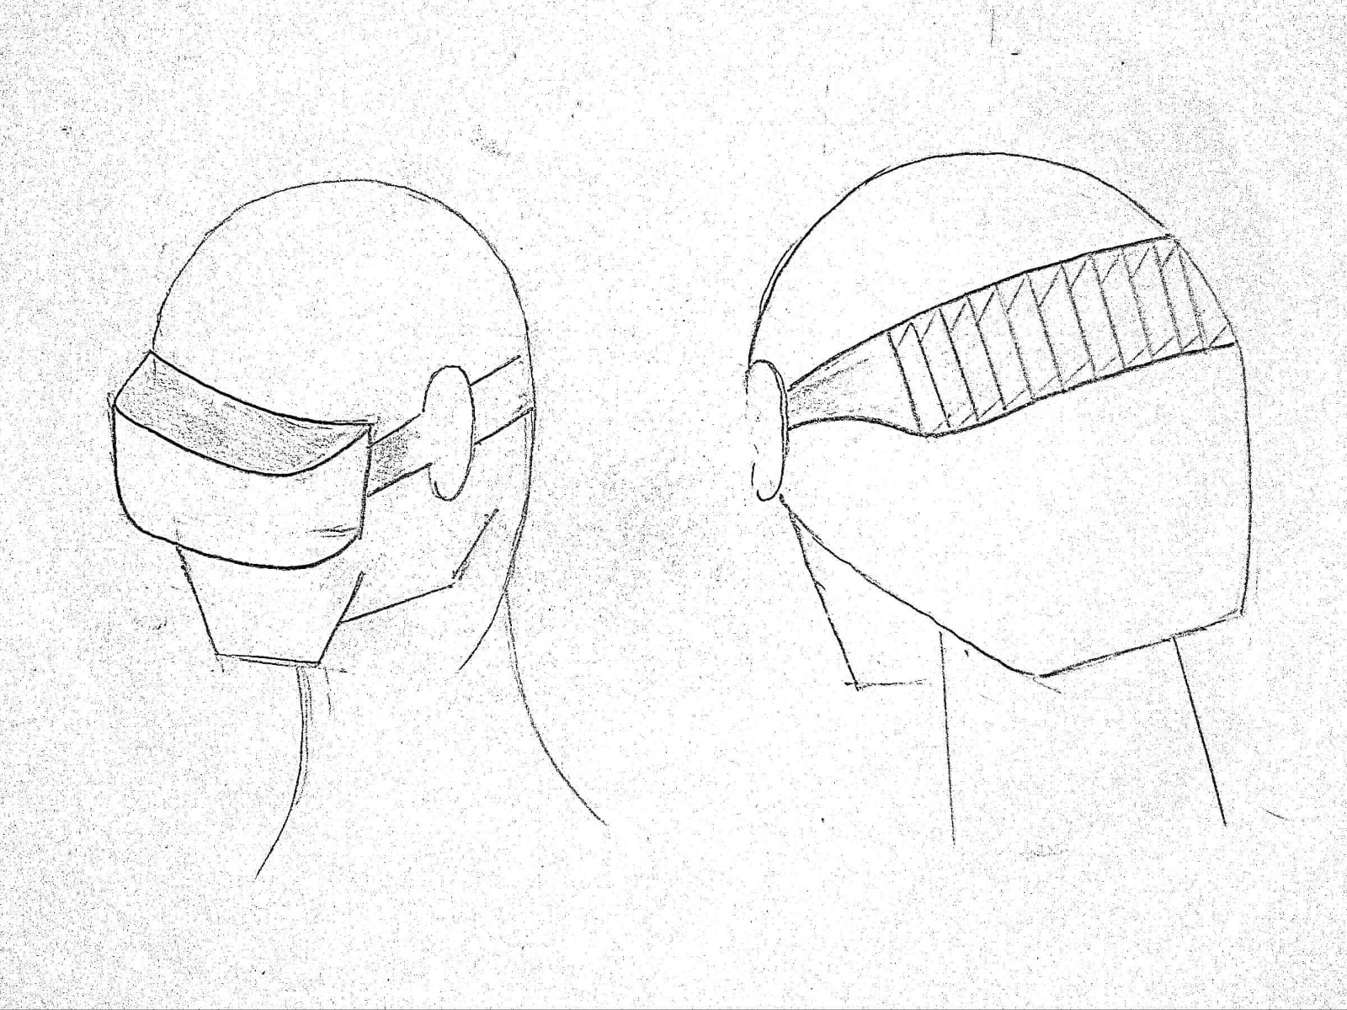

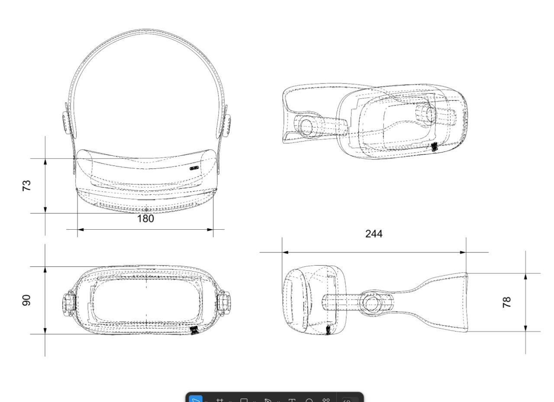

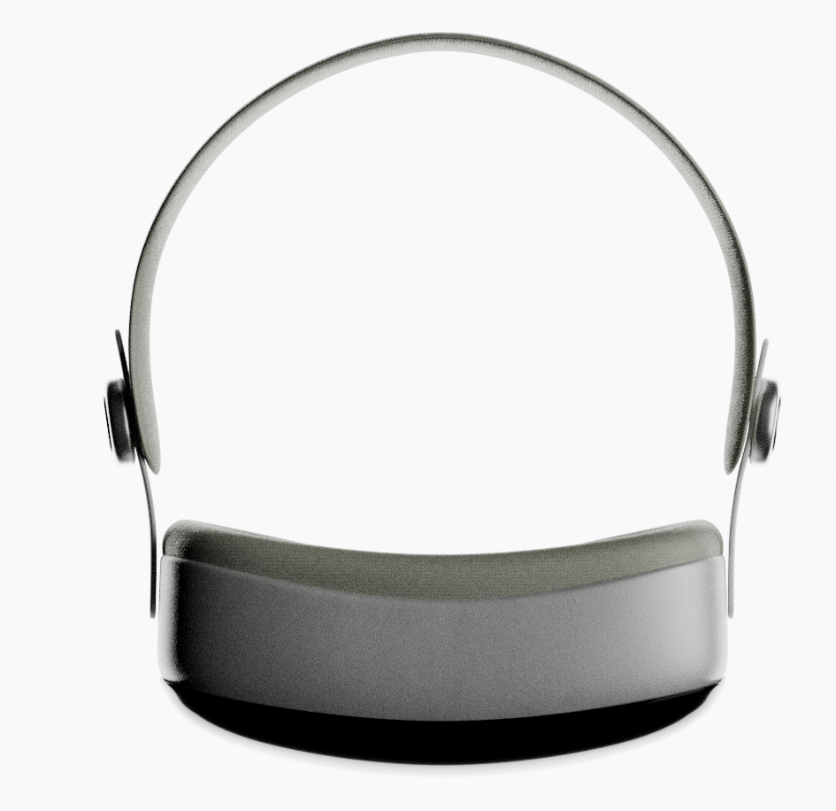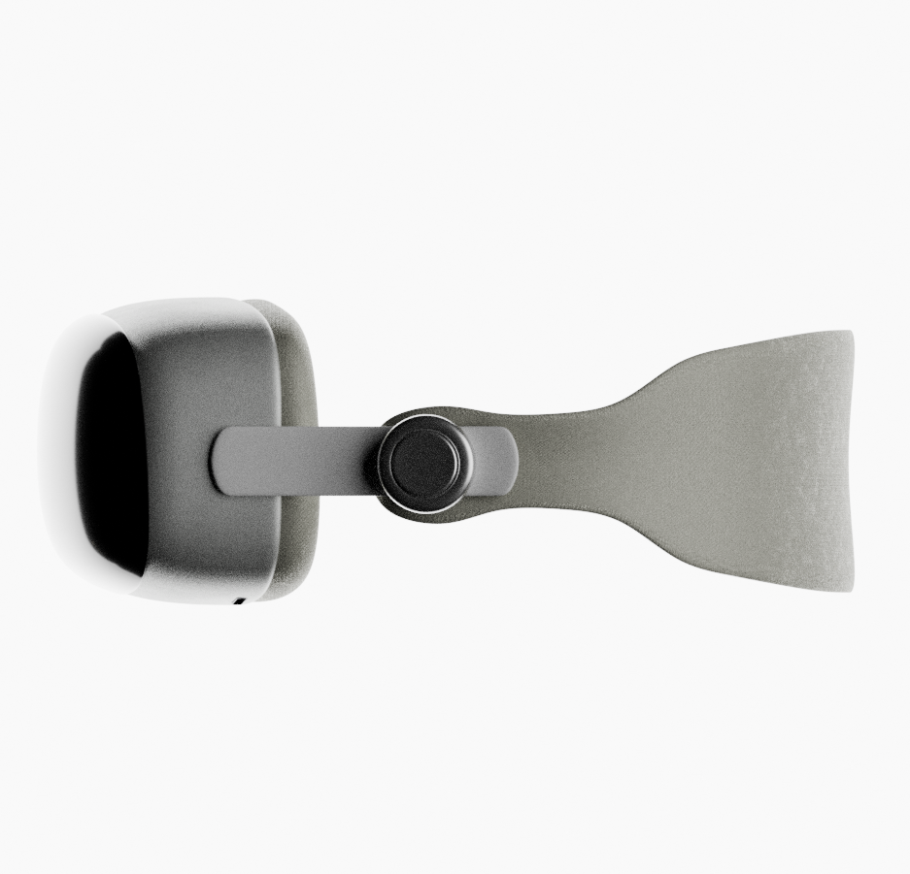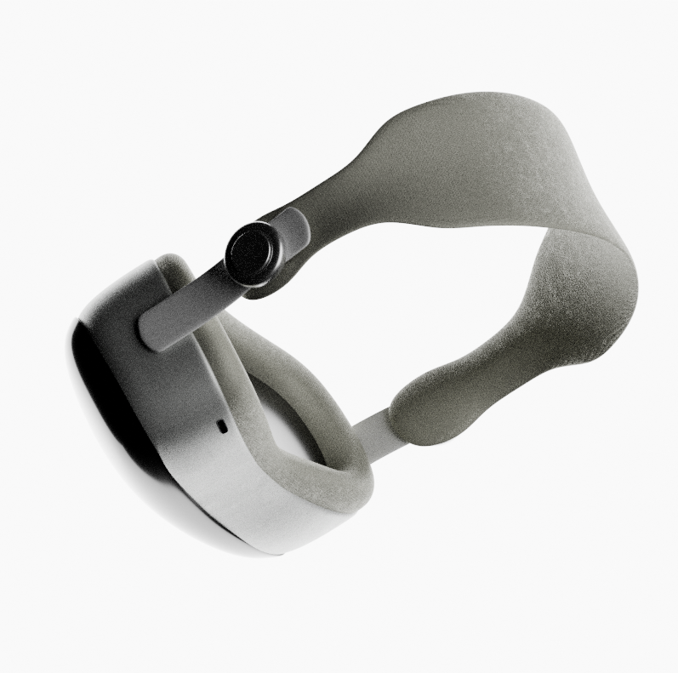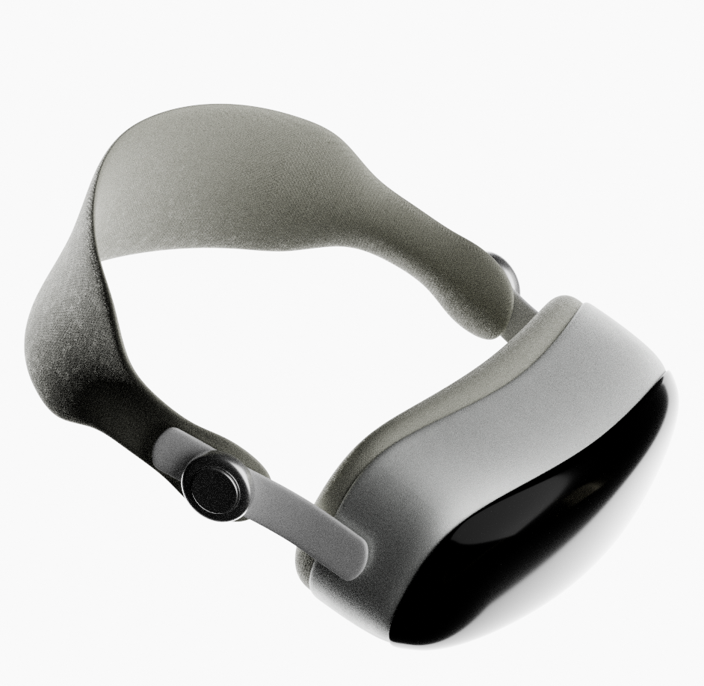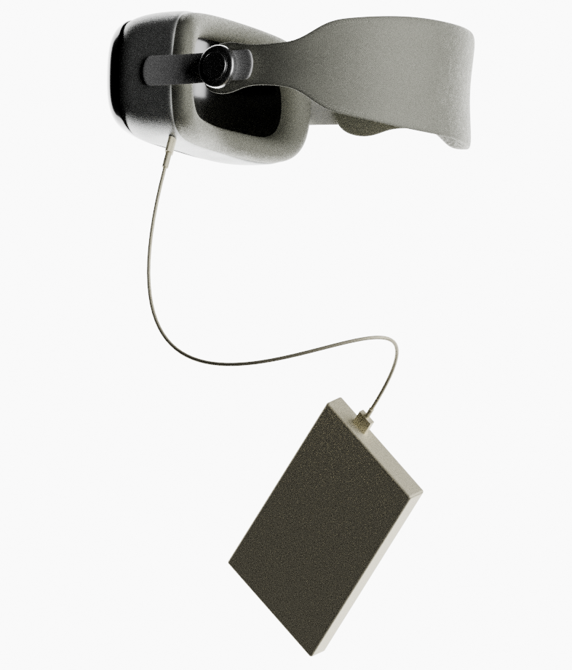

**Working**

**1. Environmental Sensing and Object Detection**

LiDAR and Camera continuously scan surroundings and detect objects.The model processes data in real-time, identifying key obstacles like walls, doors, traffic signals, and other moving entities.

**2. Data Processing & Interpretation**

The onboard microcontroller analyzes depth, motion, and object classification.AI algorithms recognize common navigation patterns, improving personalized guidance.

**3. Feedback Mechanism**

Haptic feedback motors vibrate to indicate:

Obstacle presence (strength of vibration = proximity).

Direction of obstacles (forehead = front, temples = side).

Air conduction earphones provide audio cues like:

"Obstacle ahead at 2 feet"

"Turn left to avoid barrier"

"Pedestrian crossing detected"

**4. Connectivity & Smart Updates**

WiFi & Bluetooth allow continuous improvements through AI model updates.

Users can customize sensitivity and alert preferences via a mobile companion app.

**Novelty**

**Novelty and Unique Contributions**

This wearable assistive device introduces several innovative elements that distinguish it from existing technologies:Unlike traditional mobility aids, this device resembles a headset but is lightweight, compact, and ergonomic.

**Combination of Haptic & Air Conduction Audio Feedback**

Unlike purely audio-based devices, this multi-sensory approach ensures intuitive navigation without dependency on a single sense.Uses a machine learning model for real-time object classification, enhancing accuracy in dynamic environments.

**Customizable Experience**

Users can adjust vibration intensity, audio prompts, and sensitivity settings via a smartphone application.

**Minimalist Design for Maximum Comfort**

Lightweight materials and adjustable straps ensure that the device can be worn for extended periods without discomfort.

**Bill Of Materials**

| **S.No** | **Name Of Components** | **Quantity** | **Rate/ Unit**  **(Rs)** | **Total Rate**  **(Rs)** | **Justification** |
| --- | --- | --- | --- | --- | --- |
| 1. | AMB 82 Mini Cam | 1 | 2700 | 2700 | To create bird eye for path planning |
| 2. | LiDAR | 4 | 3250 | 13000 | Used for scanning large external areas |
| 3. | Vibrational Motor | 6 | 60 | 360 | For haptic feedback with vibration |
| 4. | Power unit (20000mAH) | 1 | 1300 | 1300 | Power supply for microcontroller |
| 5. | NEO-6M GPS Module | 1 | 550 | 550 | Used for navigation system |
| 6. | CAD Printing | NA | 5000 | 5000 | For Fabrication |
| 7. | Connecting wires | NA | 100 | 500 | For Connection |
| 8. | USB Cable | 1 | 200 | 200 | Connection input through system |
| 9. | Earphone | 1 | 1500 | 1500 | For audio feedback |
| 10. | SD Card | 1 | 150 | 150 | For storage purpose |
| 11. | Buffer | NA | 3000 | 3000 | For other extra stuff required in the model |

**Total Estimated Budget: ₹28,000 - ₹30,000**

**Conclusion**

The haptic wearable navigation aid is a revolutionary step in assistive technology for visually impaired individuals. By integrating object recognition, LiDAR depth sensing, and a dual-feedback system (haptic + air conduction audio), the device enhances mobility, safety, and independence.

This innovative device offers:

A seamless, hands-free navigation experience.

Real-time obstacle detection.

A comfortable and discreet design for long-term use.

Future developments may include:

GPS integration for guided navigation.

Machine learning improvements for personalized assistance.

This device empowers visually impaired users with greater confidence, autonomy, and ease of movement in their daily lives.

**THANK YOU!**